CI/CD

(Continous Integration/Continous Delivery(OR)Deployment)

-🡪CI/CD which stands for continuous integration and continuous delivery/deployment,aims to streameline and accelerate the software development lifecycle.

Different Types of CICD tools are:

1.Jenkins(open source)

2.Gitlab(Some part is open source)

3.GitHub actions

4.Bamboos

5.Circle CI

6.Azure DevOps

7.aws DevOps

🡪Jenkins is a open source project written in Java ,that runs on windows,linux,macos.

🡪2011 first realse and Kohsuke Kawaguchi(Author)

🡪Consists of plugins

🡪It developed by sun microsystem

🡪Whenever developers write code,we integrate all the code of all developers at any point of time and we bulid ,test and deliver/deploy to client this is called CI/CD

Prequisties for Jenkins

1.Java

2.Minimum Instance Configuration(2 cpu’s ,2gb ram-🡪t2 medium)

Installation of java and Jenkins

*****

-wget(from external install 🡪google)

-yum(from internal install)

Note:-In EC2 instance internally, it has git repo but Jenkins repo doesnot have internally in EC2 instance by default.

Create IAM role to the instance

That why when you are install git we use -yum

And install Jenkins first you need to install the repo from external that why we use the -wget

<https://github.com/CloudTechDevOps/Terraform-09-00am/blob/main/project-terraform-devops-tools-install/install.sh>

sudo yum update -y

#---------------git install ---------------

sudo yum install git -y

1#-------java dependency for jenkins------------

sudo dnf install java-11-amazon-corretto -y

2#------------jenkins install-------------

sudo wget -O /etc/yum.repos.d/jenkins.repo https://pkg.jenkins.io/redhat-stable/jenkins.repo

sudo rpm --import https://pkg.jenkins.io/redhat-stable/jenkins.io-2023.key

sudo yum install jenkins -y

sudo systemctl enable jenkins

sudo systemctl start Jenkins

Jenkins --version(to the know whether Jenkins is present or not)

If you want know your Jenkins start or not use the following command

systemctl status Jenkins

-🡪 BY default Jenkins will run the port number 8080

-🡪public ip (http) the default port number is 80

TO ACCESS JENKINS:

Public ip :8080 (default port number of Jenkins)

NOTE: If the web page doesnot respond check the security group and add the 8080 port number

Unlock Jenkins

------------------------------------------------------------------------

sudo su –

cd /

ls

** Inside var Jenkins folder will be created

cd var

cd lib

ls

cd Jenkins/

ls

cd secrets/

ls

cat initialAdminPassword

--------------------------------------------------------

# cat /var/lib/Jenkins/secrets/initialAdminPassword

paste the password in Jenkins which are copy from ec2(the password comes after excute the above command) and click on the continue.

-🡪install suggested plugins

And create your own password and start with your jenkins

Jenkins server---🡪our Jenkins host on the EC2 instance /server it will becomes the Jenkins Server

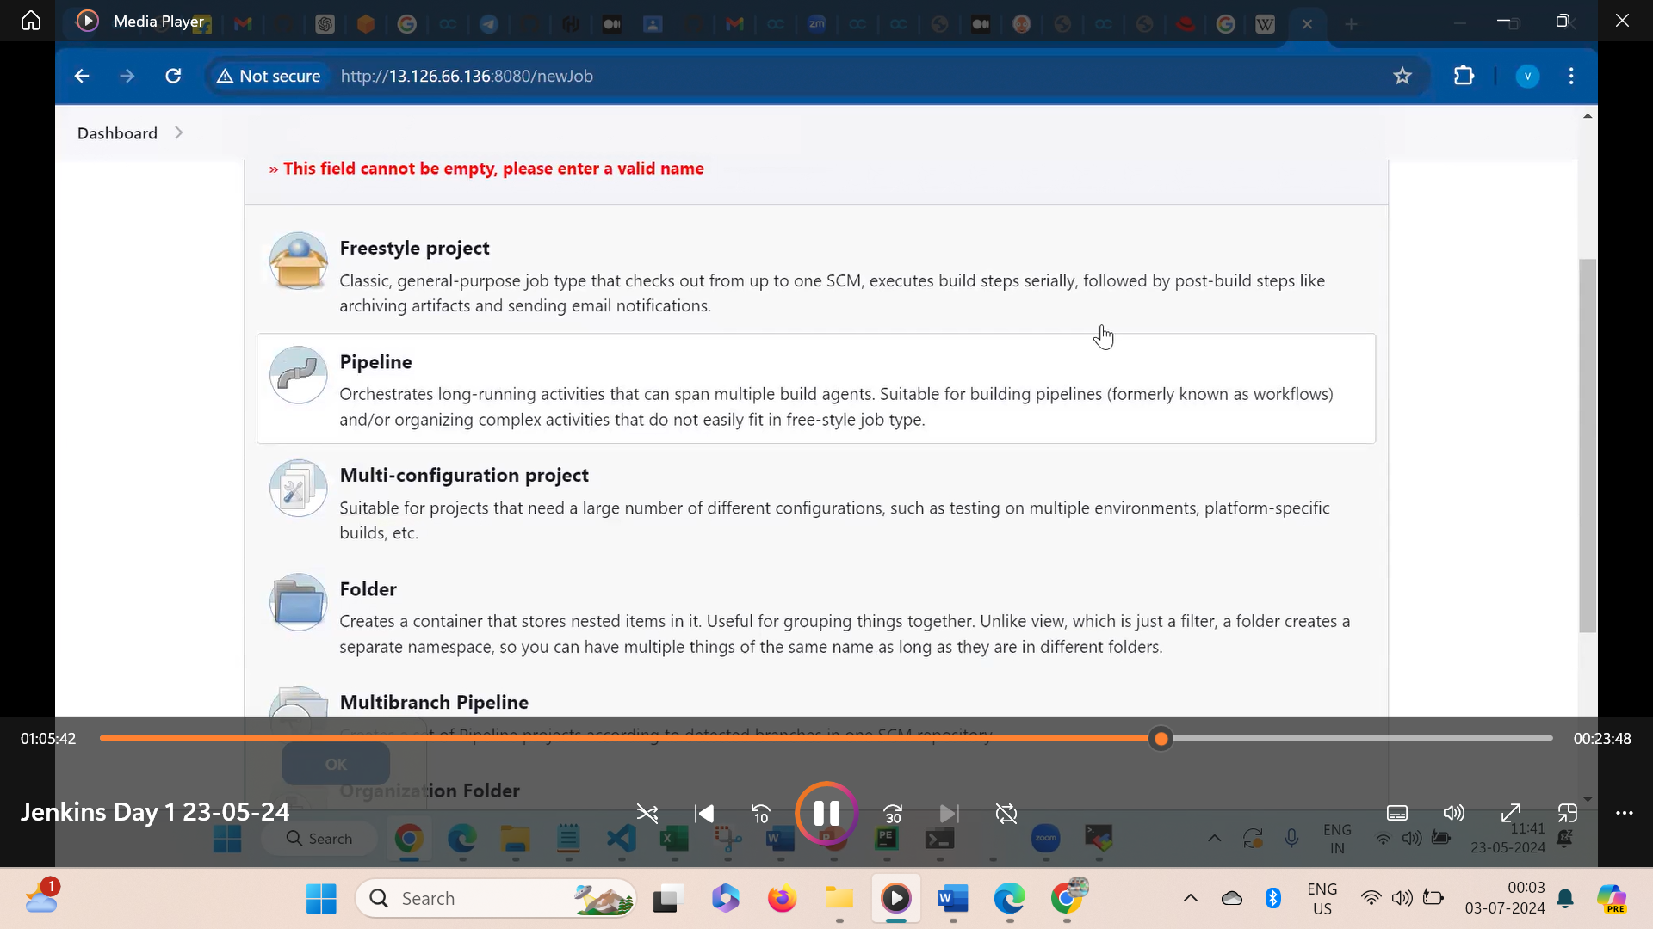

After selecting the pipeline

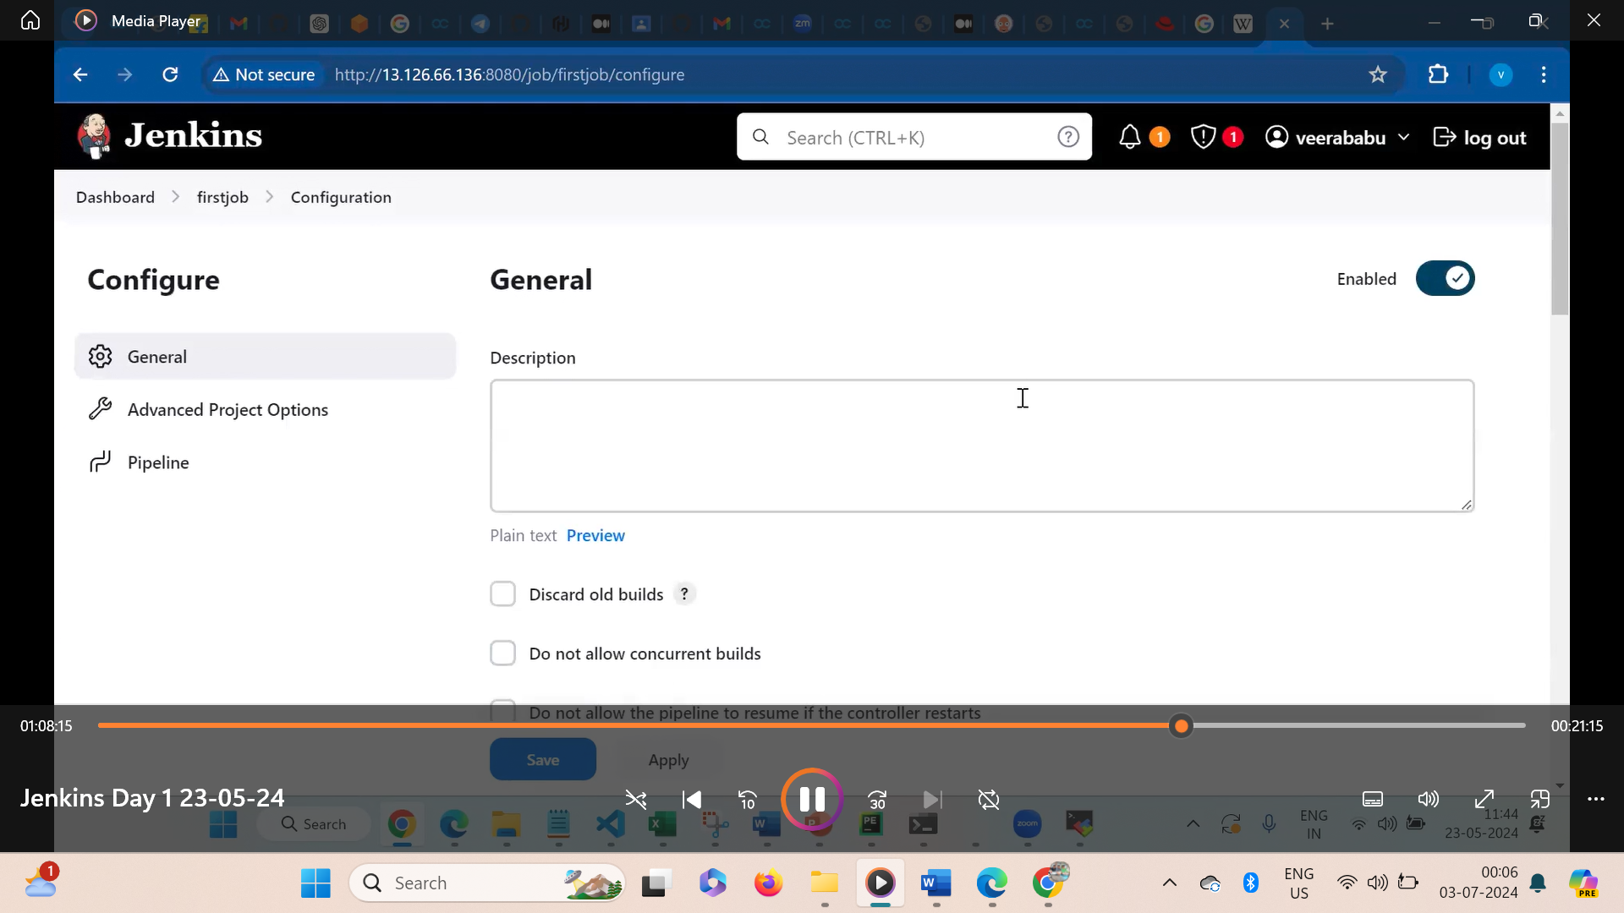

PipeLines are 2 types:

1.Declaritive Script( starts with pipeline while writing the Scrips)

2.Gurvi Script

Sample Pipe line

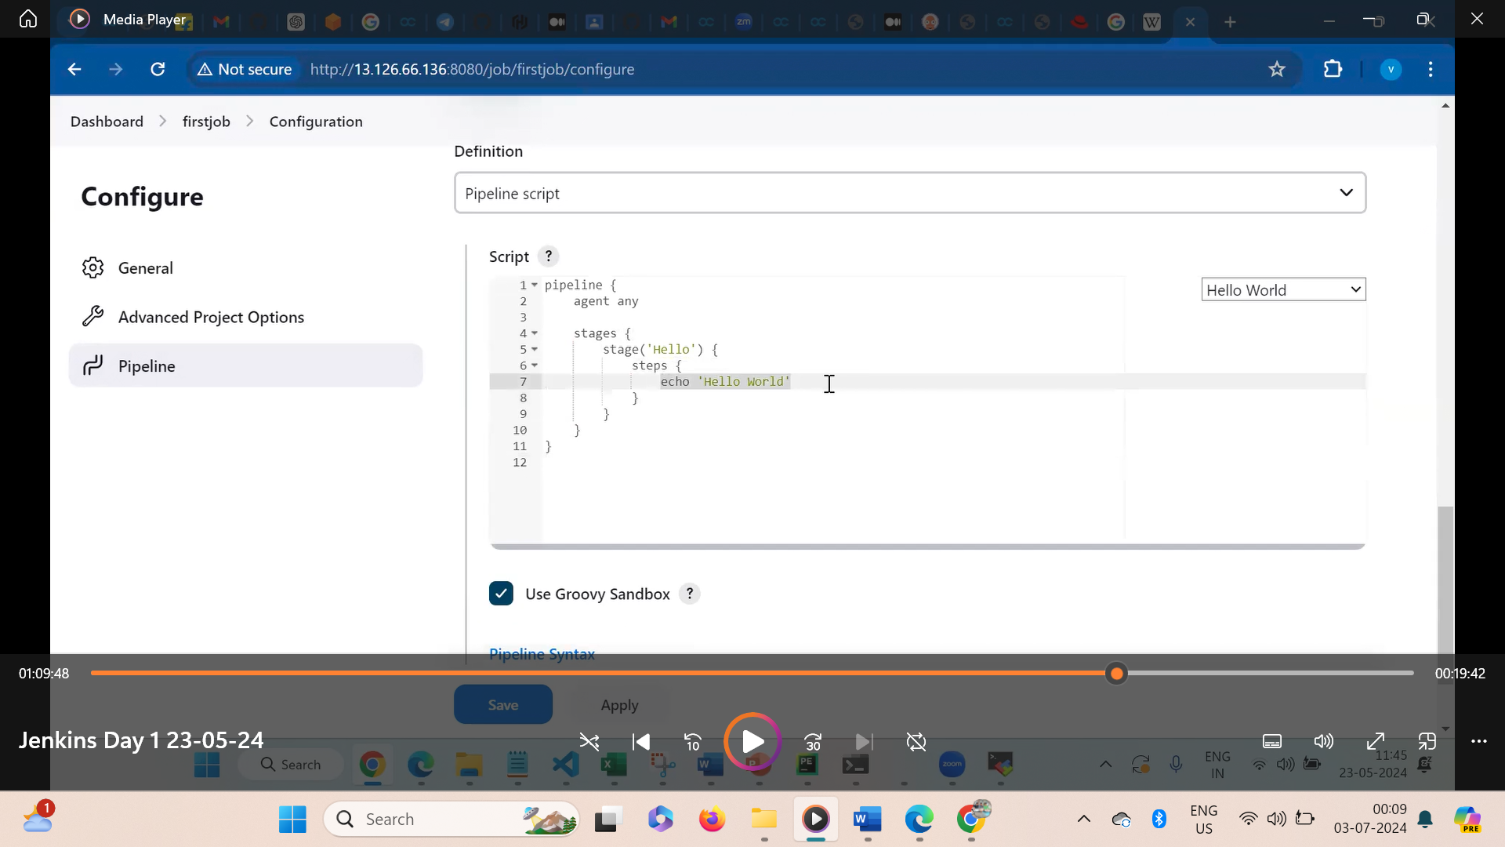

After writing the script click on apply and save ---build now

All commands in scripts are under sh (starts with sh. Ex:- ssh ‘touch file’)

Here sh means =shell

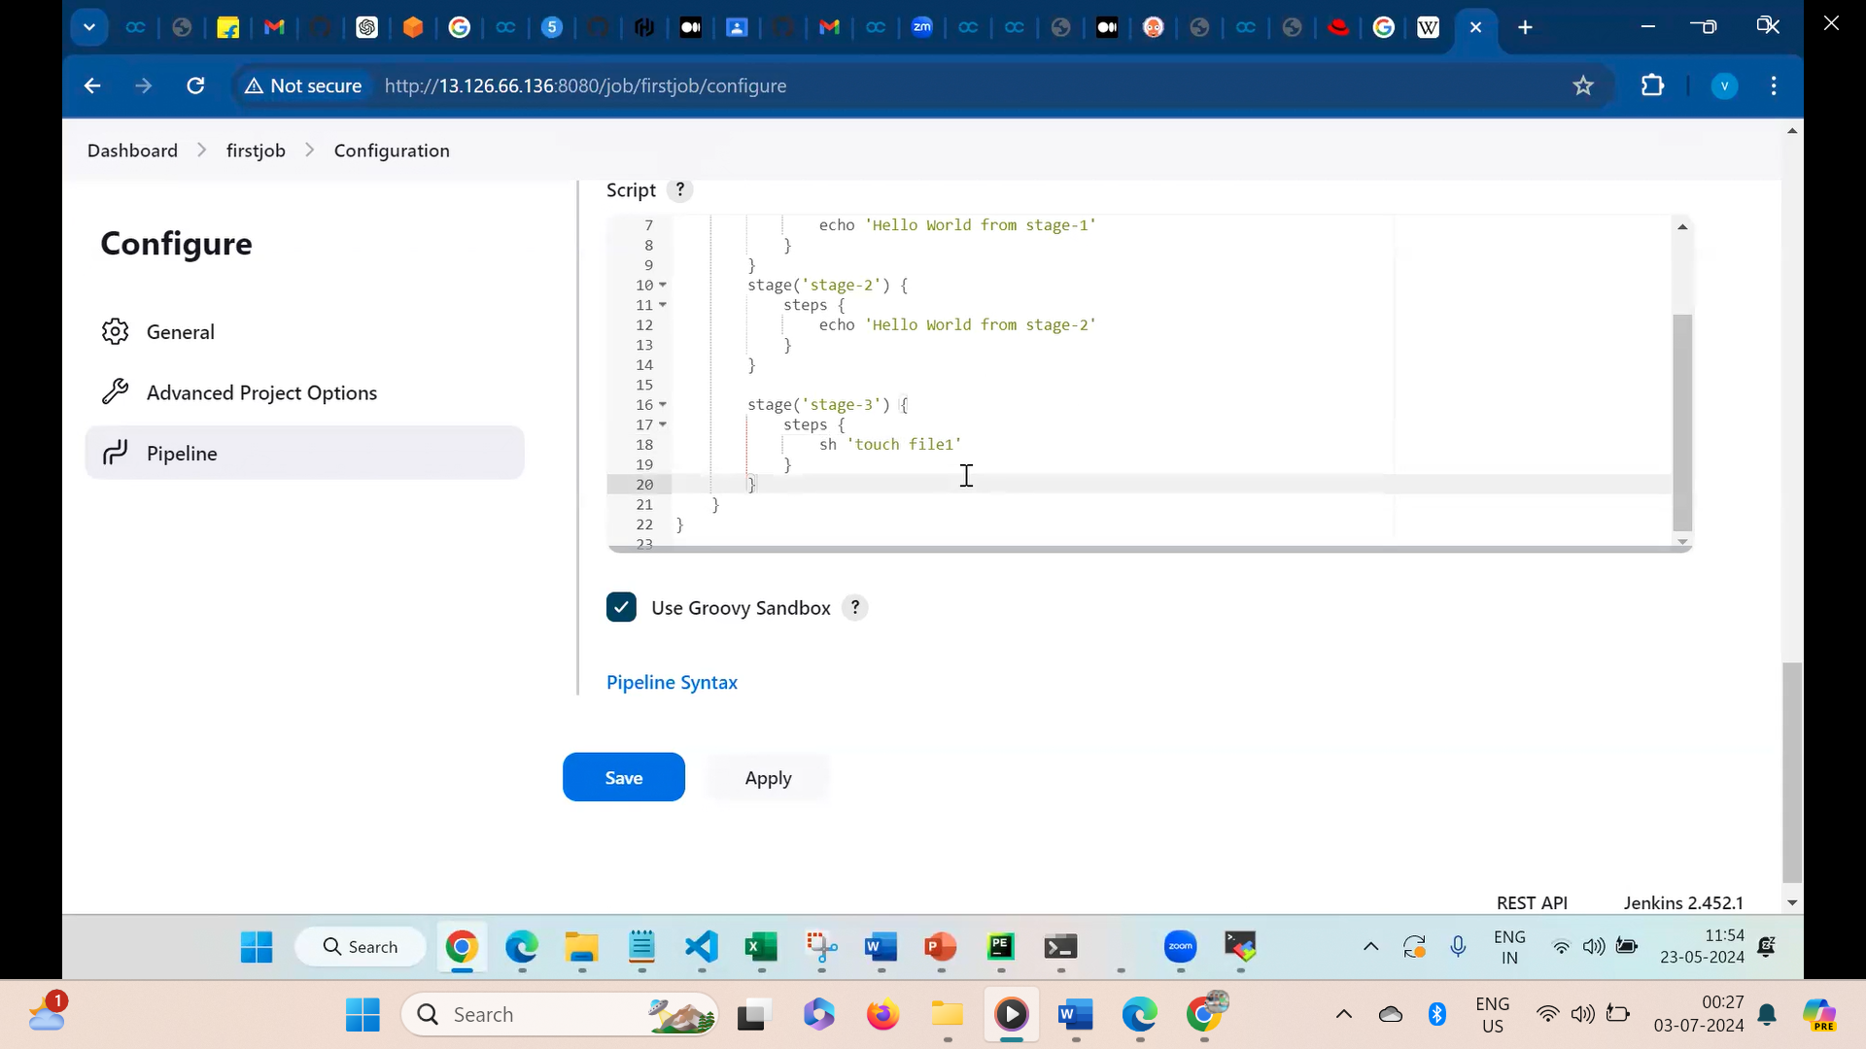

Question :where this file will be created ?

Ans:- Jenkins work space

Method 1:Through cmd (server)

cd /var/lib/jenkins/

ls

workspace

cd workspace

ls

cd firstjob(it is the job and this name given by you when you create the job in Jenkins dashboard)

ls

file1

Method 2:-Through Jenkins

Workspace

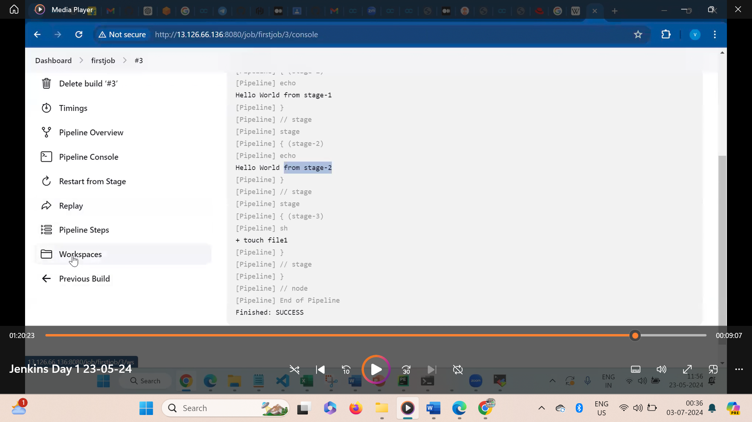

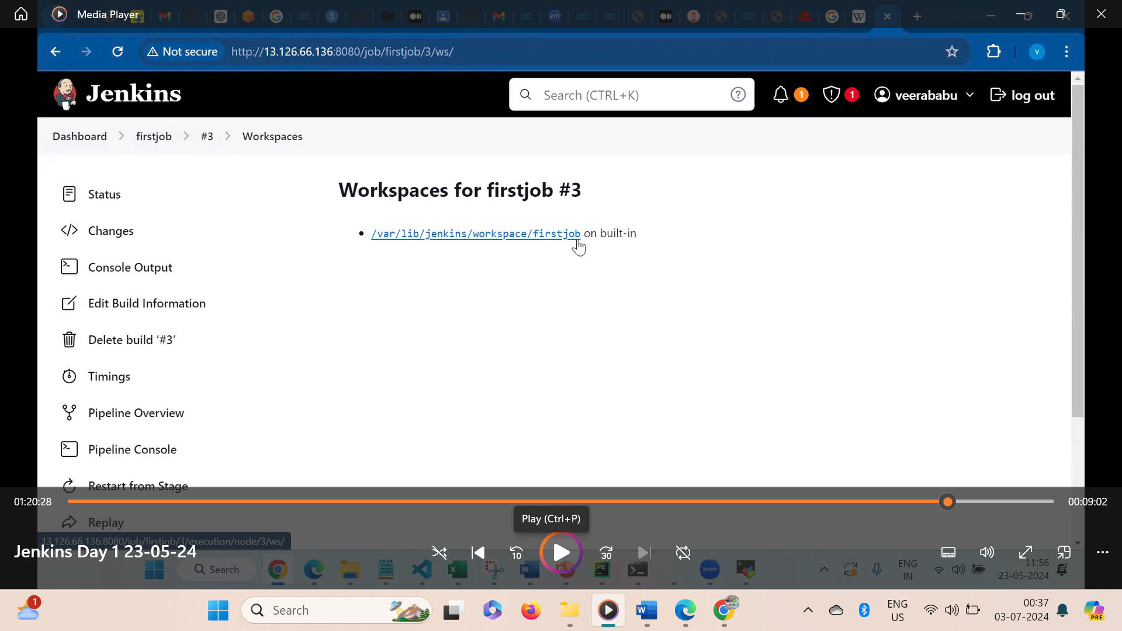

Click on the link

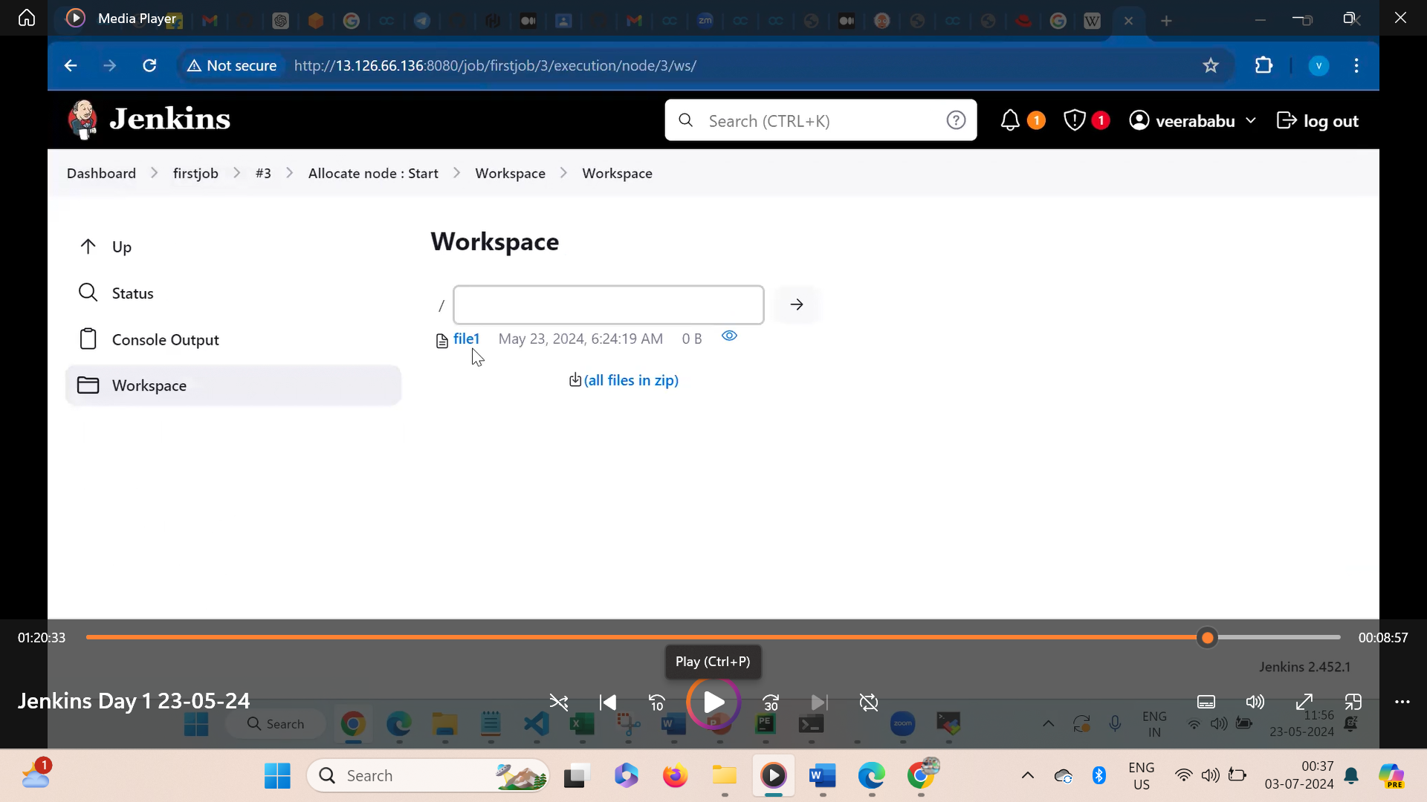

Now you can see the file1

--------------------------------------------------------------------------